**Spring 2021 ECE 330**

**Homework-6**

Submitted by: Oshan Poudyal (101846248)

Submitted to: Mr. Amir Raeisi Nafchi

**Homework #6**

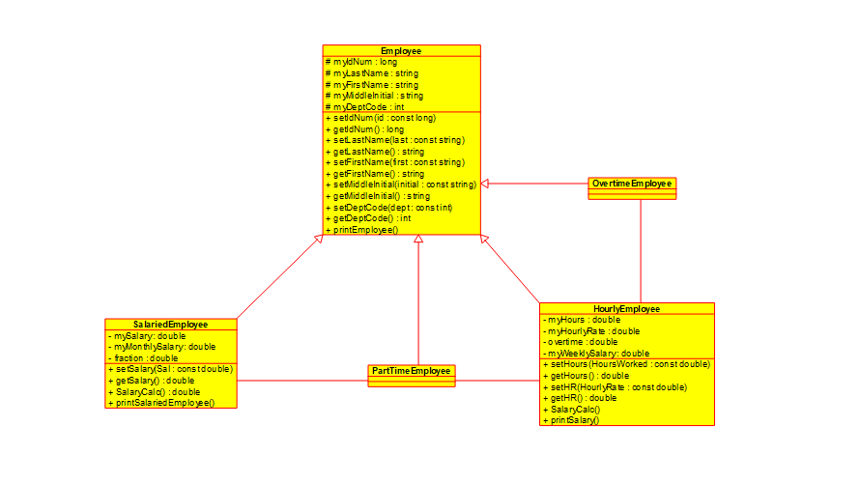

Here, I have used a class diagram to show all my derived classes, SalariedEmployee and HourlyEmployee that we used from the super class Employee from Homework 4.

The super class has secured member variables listed in the upper box and public member functions in the lower box. The derived classes inherit these functions in their classes too. Also, the derived classes have their own separate private members and public functions. I have also added two more classes OvertimeEmployee and PartTimeEmployee as derived classes from Employee.

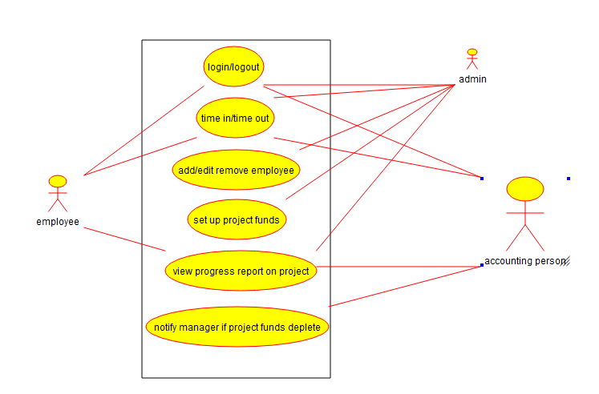

Then, I used the above use-case diagram to show the basic functionalities of the design. Login/Logout, time in/time out functionalities are accessible by everyone. But some of the funding management related functions are only accessible by the admin. I have also added the accounting person as an actor to access the wages of the employees and view progress report of the project. Based on this report, he has the permission to alert the manager if the project funds are depleted.

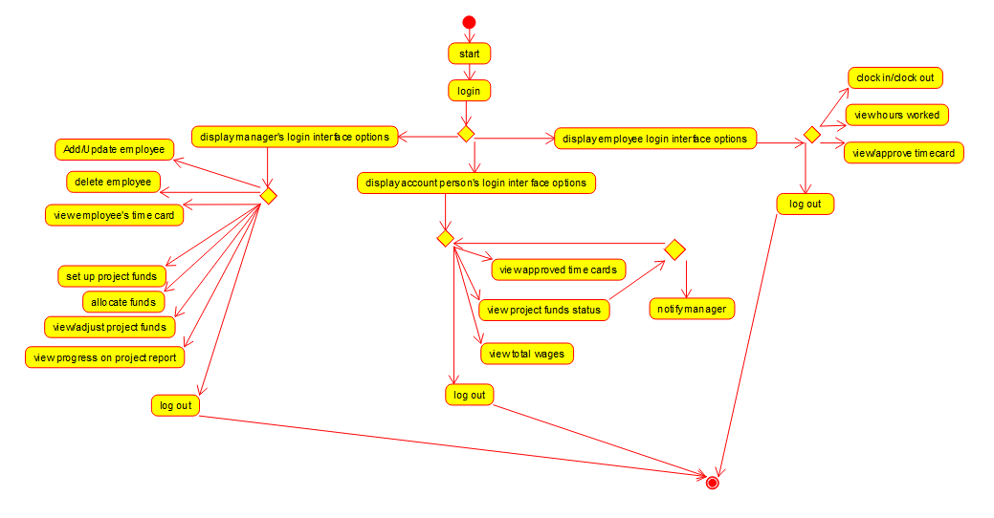

Here, the above activity diagram shows the basic functionalities. It starts with the login and depending on the user’s credentials, it is divided into three categories which are: regular employees, manager and accounting clerks. Based on these categories, I have then added separate functionalities based on their authorizations. An example: a regular employee only has the functionality to clock in or clock out, view their hours worked and approve their timecard whereas the manager has access to add, edit, delete employees, and set up or allocate or adjust the project funds.

Overall, this was a very good learning experience getting to do this design exercise. Thank you Amir for your help.